Practical no. 22
Name :- Danish Altaf Solkar Enrolment no. :-24111590805
Class :- CO3K – B Subject :- OOP
Aim :- Write a program which show the use of Abstract class.
Program :-
#include <iostream.h>
#include <conio.h>
class Shape {
public:
virtual void draw() = 0;
};
class Circle : public Shape {
public:
void draw() {
cout << "\n Drawing a circle...";
}
};
void main() {
clrscr();
Circle c;
c.draw();
getch();
}
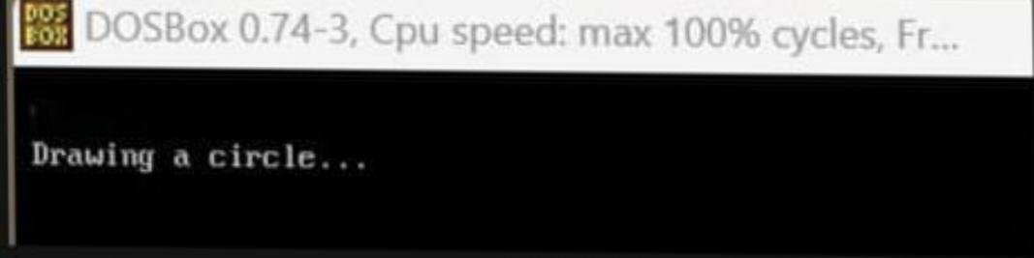
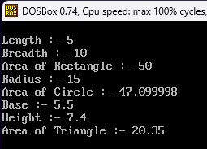
Output :-

